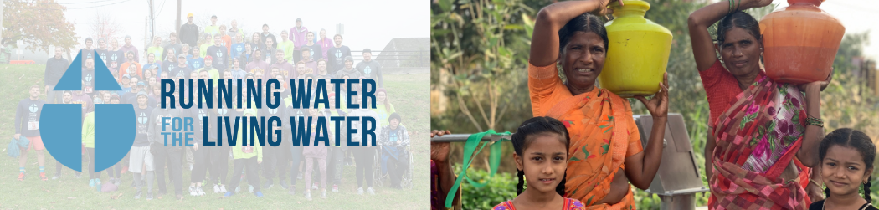

Dear ________________________________,

As a part of the Running Water for the Living Water campaign, I will be running in the Harrisburg Marathon in November. Our purpose is to raise funds to drill wells in India and Africa, where many are in desperate need of clean running water. Our group is partnering with Global Partners in Peace and Development (GPPD) for the construction of these water wells.

GPPD is a 501(c)(3) non-profit committed to charitable, developmental, and educational work around the world. Currently, GPPD has 446 wells in use, mostly in South Asia. All gifts are tax-deductible and 95% of all donations go directly to causes. You can read more about their water well program at gpartners.org/water.
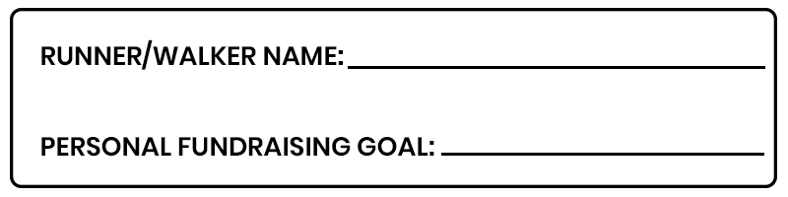
Any financial contribution that you could make would be greatly appreciated. On average, $5 can provide 1 person clean water for a lifetime. If you choose to donate, you will receive pictures and a video of the well and people impacted, as well as a map of the exact location. Donations and sponsorship can be made at gpartners.org/RW or by mailing in the form included with this letter. Thank you for your consideration of helping provide clean water to those in poverty.

Sincerely,

_____________________________

If you have any questions, contact me or Matt Riggins at mriggins@gpartners.org (717-877-2313).
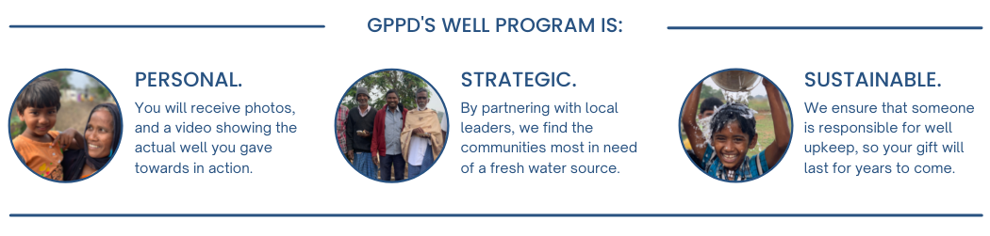

DONATE ONLINE

Visit gpartners/org/RW and click “Donate to a Runner” at the very top of the page.
You will be prompted to choose a runner to support during checkout.

F

DONATE BY MAIL
Yes! I would like to provide clean water to people in poverty. I pledge…

______$20 ______$50 ______$75 ______Other

______$100 Sponsor a mile for $100

OR BECOME A SPONSOR by donating $250 or more.

_______BRONZE - $250 Business or individual’s name (no logo) on back of team t-shirt
_______SILVER - $500 All of the above plus: Sponsor logo (or name if preferred) on shirt
_______GOLD - $1000 All of the above plus: Framed picture of well dedication
_______DIAMOND - $2600 All of the above plus: Fully personalized video of the well dedication, sponsor name or phrase of choice to appear on banner at well site

DONOR INFORMATION (PLEASE CHECK ONE ABOVE)

Runner: _____________________________________________________________________
If left blank, your donation will be applied to group fundraising goal
*Name/Business: _________________________________________________________________
*Address: ________________________________________________________________________
*Email: __________________________________________________________________________
**email will be used to share location, pictures, and video footage of the well you donated to.

Check Included for $_____________ (to Global Partners in Peace and Development)
GPPD (Tax ID # 75-3098074) will mail a receipt for all donations sent to the office

