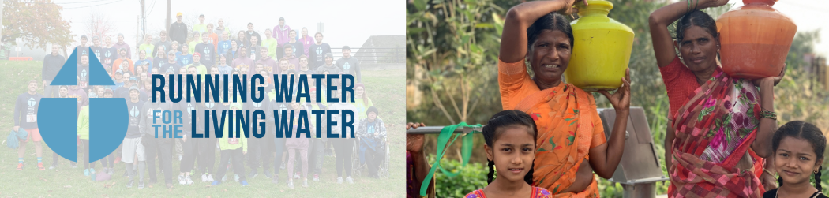

Dear ________________________________,

Today, the water crisis is causing millions of people around the world to suffer. For 7 years, Running Water for the Living Water team members have run in the Harrisburg Marathon to break the cycle and install wells in needy communities in Asia and Africa!

As a part of the team, I will be running in the Harrisburg Marathon/Relay in November. Our group is partnering with Global Partners in Peace and Development, a 501c3 nonprofit, for the construction of these wells. (gpartners.org/water). Your support today will have a ripple effect for a lifetime!

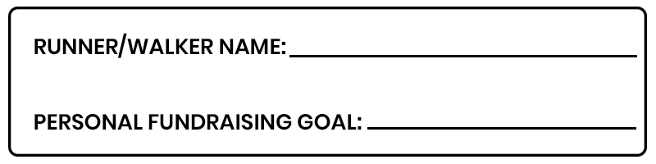
Any financial contribution that you could make would be greatly appreciated. On average, $5 can provide water for one person. If you choose to donate, you will receive pictures and a video of the well and people impacted, as well as a map of the exact location. Donations and sponsorship can be made at give.gpartners.org/RW23 or by mailing in the form included with this letter. Thank you for your consideration of helping provide clean water to those in poverty.

Sincerely,

_____________________________

If you have any questions, contact me or Matt Riggins at mriggins@gpartners.org (717-877-2313).
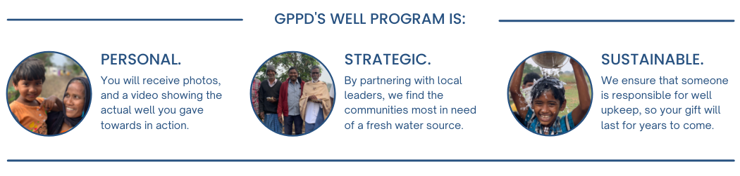

DONATE ONLINE

Visit give.gpartners.org/RW23

F

DONATE BY MAIL
Yes! I would like to provide clean water to people in poverty. I pledge…

______$20 ______$50 ______$75 ______Other

______$100 Sponsor a mile for $100

OR BECOME A SPONSOR by donating $250 or more.

_______BRONZE - $250 Business or individual’s name (no logo) on back of team t-shirt
_______SILVER - $500 All of the above plus: Sponsor logo (or name if preferred) on shirt
_______GOLD - $1000 All of the above plus: Framed picture of well dedication
_______DIAMOND - $2600 All of the above plus: Fully personalized video of the well dedication, sponsor name or phrase of choice to appear on banner at well site

DONOR INFORMATION (PLEASE CHECK ONE ABOVE)

Runner: _____________________________________________________________________
If left blank, your donation will be applied to group fundraising goal
*Name/Business: _________________________________________________________________
*Address: ________________________________________________________________________
*Email: __________________________________________________________________________
**email will be used to share location, pictures, and video footage of the well you donated to.

Check Included for $_____________ (to Global Partners in Peace and Development)
GPPD (Tax ID # 75-3098074) will mail a receipt for all donations sent to the office

