SPONSORSHIP LEVELS

Please choose a sponsorship impact level below. Businesses and individuals who support Running Water for Living Water will receive photos and a video of the well they contributed to.

BRONZE: $250
Sponsor’s name (no logo) will appear on the t-shirt worn by runners at the event

SILVER: $500
All of the above plus: Sponsor’s logo (or name if preferred) will appear on
team t shirt and fundraising webpage

GOLD: $1,000
All of the above plus: Well video includes a personal thank you message to you and other donors(s),

DIAMOND: $2600 (ENTIRE WELL)
All of the above plus: Fully personalized video of the well dedication (not shared with other donors),
Framed Commemorative photo gift, Sponsor name to appear on banner at well site

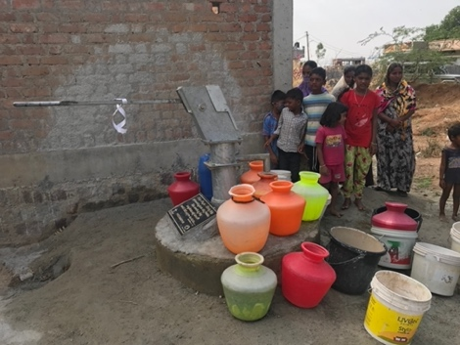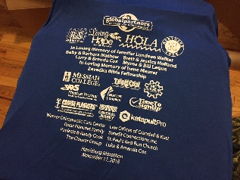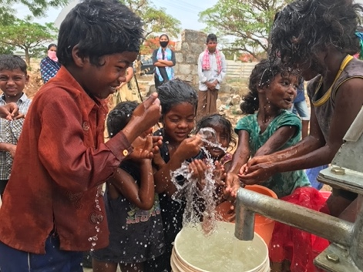

Mail in form on next page. To register and pay online, please visit our website at gpartners.org/RW.

running water for the living water
sponsorship form

*Name: ___________________________________________________________________________
Business Name (*for business sponsors) _______________________________________________
*Address: _________________________________________________________________________
Phone Number: ____________________________________________________________________
*E-mail: ___________________________________________________________________________
Name of Runner(s) you are Sponsoring: _______________________________________________

Yes, I would like to sponsor this year’s marathon to help provide water wells in India:

Bronze Sponsor ($250+) $________________

Silver Sponsor ($500+) $________________

Gold Sponsor ($1,000+) $________________

Diamond Sponsor ($2,600+) $________________

Bottled Water or Gatorade, or Individual nonperishable snacks for runners

Custom Amount $________________

Please keep my donation anonymous

- Checks payable to GPPD can be mailed with form to P.O. Box 117, Blue Ridge, VA 24064.
- To Pay with Card, visit: www.gpartners.org/RW and scroll down to the sponsorship section
- 95% of your donation goes directly to building wells. Only 5% is used for well administrative needs. Charitable contribution receipts will be provided to all donors.
- Please kindly send in any t shirt graphics to mriggins@gpartners.org by October 20. Deadline extensions may be possible if the shirt order has not yet been placed.
- If you have any questions, contact Matt Riggins at mriggins@gpartners.org (717.877.2313)

